**Laser trigger mode:**

* Measure trigger delay & jitter
* Typical rates ~ 50-100

DAQ Channel:

* every laser trigger signal should send out one trigger signal to DAQ for optoacoustic imaging
* programmable delay
* trigger on duration = 1us, 500 ns min!

Camera Channel

* trigger every n-laser triggers
* trigger on duration??

Stimulus channel

* n-shots base line recording + i-shots stimulus recording, every j-shots
  + (eg. 2s baseline + 5s stimulus, then wait 10s)

Blocking Channel

* Trigger high when not recording stimulus or baseline
* Do not trigger daq / camera during this time

**Standalone Mode**

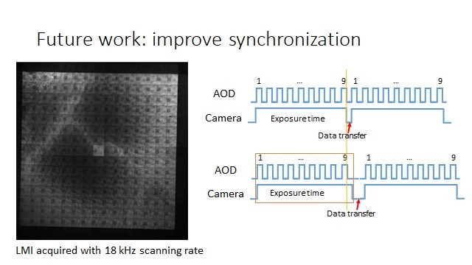

* Trigger AOE 9 times, 50% duty cycle, several kHz trigger rate
  + Min trigger time = 8 ns, 5V
* Specify trigger rate
* Trigger camera constantly for all 9 cycles (make sure to use full last cycle)
* Wait n-seconds before triggering again for camera to do it’s thing

**4k FPS Camera Triggering Notes**

* External Exposure Control (Ext. Exp. Ctrl)
  + An external signal, applied to the trigger input (BNC exposure trigger), controls start and duration of the exposure
  + a new exposure starts by the **falling or rising edge** of the voltage signal at the BNC input
  + The exposure ends when the opposite edge is detected.
  + in this mode, the start as well as the length of the exposure time can be controlled externally
  + No further settings can be made, as the image timing is completely controlled by the exposure trigger signal
  + **maximum exposure time 20ms**
  + **timing**
    - 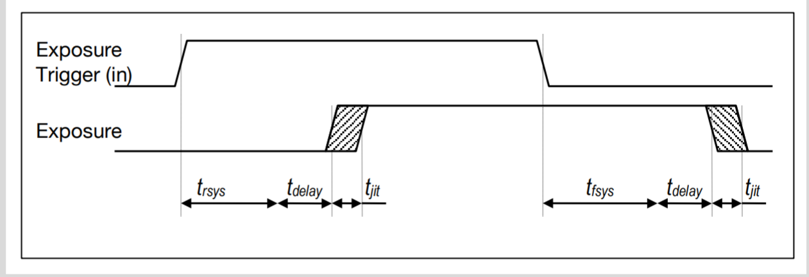
    - timing for external trigger includes **system delay times**, an **adjustable additional delay time and the jitter**
    - **tjit:** -0 /+25ns
    - **tdelay:** 0…1ms
    - trsys + tfsys system delay times depending on ROI
    - both are ~ 2-3 us, if this is a problem we can trigger earlier and stop earlier…
      * depends on trigger time for the 9 triggers required…
    - triggers can be very short apparently, but for this application trigger time = exposure time